Secure Sight Statistical Analysis Report

Total runs: 25
Total batches: 5

Global Metrics

Metric | Mean | Std Dev | Variance | Min | Max | Median | Count
accuracy | 0.882542 | 0.01936455760358606 | 0.000360 | 0.848468 | 0.915821 | 0.884026 | 25
precision | 0.872027 | 0.025589078274550536 | 0.000629 | 0.827591 | 0.928699 | 0.876727 | 25
recall | 0.883841 | 0.02557295703021548 | 0.000628 | 0.837560 | 0.929544 | 0.886608 | 25
f1_score | 0.875067 | 0.020588334352271184 | 0.000407 | 0.836546 | 0.914991 | 0.873292 | 25
auc | 0.895226 | 0.02783259496311161 | 0.000744 | 0.842868 | 0.948310 | 0.899564 | 25
latency | 9.411680 | 1.4892998067497136 | 2.129293 | 7.755605 | 12.088238 | 9.603186 | 25

Confidence Intervals

Metric | Mean | CI Lower | CI Upper
accuracy | 0.882542 | 0.874548 | 0.890535
precision | 0.872027 | 0.861464 | 0.882590
recall | 0.883841 | 0.873285 | 0.894397
f1_score | 0.875067 | 0.866569 | 0.883566
auc | 0.895226 | 0.883737 | 0.906715
latency | 9.411680 | 8.796927 | 10.026433

3. Per-Batch Metrics

Batch 1
Metric | Mean | Std Dev | Variance | Min | Max | Median
accuracy | 0.886268 | 0.01194442155754667 | 0.000114 | 0.868468 | 0.895821 | 0.891550
precision | 0.872166 | 0.024619315734056523 | 0.000485 | 0.847591 | 0.908699 | 0.876727
recall | 0.892712 | 0.02199454607605115 | 0.000387 | 0.857560 | 0.909544 | 0.901569
f1_score | 0.882289 | 0.013101402848217064 | 0.000137 | 0.860718 | 0.892784 | 0.883216
auc | 0.898001 | 0.018620549397197966 | 0.000277 | 0.868274 | 0.911645 | 0.909564
latency | 7.942580 | 0.1242790794006885 | 0.012356 | 7.755605 | 8.069188 | 8.002655

Batch 2
Metric | Mean | Std Dev | Variance | Min | Max | Median
accuracy | 0.860797 | 0.012714226039313771 | 0.000129 | 0.848468 | 0.875821 | 0.859678
precision | 0.847039 | 0.026059802354930654 | 0.000543 | 0.827591 | 0.888699 | 0.831088
recall | 0.862315 | 0.024222705933271325 | 0.000469 | 0.837560 | 0.889544 | 0.865344
f1_score | 0.855875 | 0.014457348164581853 | 0.000167 | 0.840718 | 0.872784 | 0.861940
auc | 0.869743 | 0.021188960676254497 | 0.000359 | 0.848274 | 0.891645 | 0.870957
latency | 7.955887 | 0.13538497029374835 | 0.014663 | 7.755605 | 8.069188 | 8.002655

Batch 3
Metric | Mean | Std Dev | Variance | Min | Max | Median
accuracy | 0.902635 | 0.01638551172395041 | 0.000215 | 0.881516 | 0.915821 | 0.911550
precision | 0.894962 | 0.021758254725068156 | 0.000379 | 0.871088 | 0.928699 | 0.896727
recall | 0.902107 | 0.02581273231739681 | 0.000533 | 0.872475 | 0.929544 | 0.909386
f1_score | 0.895396 | 0.021076724004960655 | 0.000355 | 0.866546 | 0.914991 | 0.901940
auc | 0.914132 | 0.031954303662711785 | 0.000817 | 0.872868 | 0.948310 | 0.929564
latency | 9.634360 | 0.20516477632479757 | 0.033674 | 9.306726 | 9.858685 | 9.683026

Batch 4
Metric | Mean | Std Dev | Variance | Min | Max | Median
accuracy | 0.872635 | 0.01638551172395041 | 0.000215 | 0.851516 | 0.885821 | 0.881550
precision | 0.864962 | 0.02175825472506816 | 0.000379 | 0.841088 | 0.898699 | 0.866727
recall | 0.872107 | 0.02581273231739681 | 0.000533 | 0.842475 | 0.899544 | 0.879386
f1_score | 0.865396 | 0.021076724004960655 | 0.000355 | 0.836546 | 0.884991 | 0.871940
auc | 0.884132 | 0.031954303662711785 | 0.000817 | 0.842868 | 0.918310 | 0.899564
latency | 9.634360 | 0.20516477632479757 | 0.033674 | 9.306726 | 9.858685 | 9.683026

Batch 5
Metric | Mean | Std Dev | Variance | Min | Max | Median
accuracy | 0.890374 | 0.009808132162759992 | 0.000077 | 0.881704 | 0.901695 | 0.884026
precision | 0.881007 | 0.009771394653209288 | 0.000076 | 0.864985 | 0.889313 | 0.881116
Recall | 0.889965 | 0.014392742289228875 | 0.000166 | 0.869431 | 0.906155 | 0.886608
f1_score | 0.876381 | 0.010626368899567607 | 0.000090 | 0.862733 | 0.891283 | 0.873292
Auc | 0.910123 | 0.010519467412790997 | 0.000089 | 0.892192 | 0.919748 | 0.911934
Latency | 11.891212 | 0.18460271633512396 | 0.027263 | 11.694424 | 12.088238 | 11.970417

4. Correlation Analysis
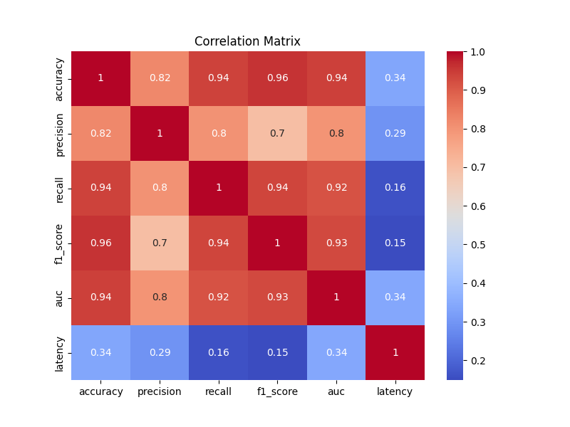

5. Visualizations
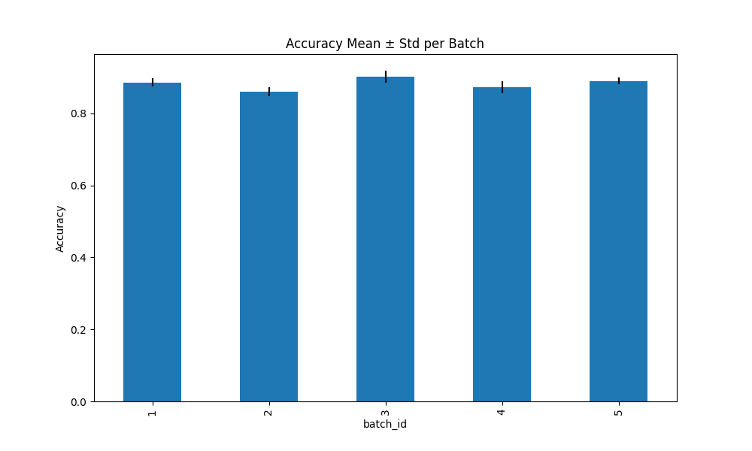

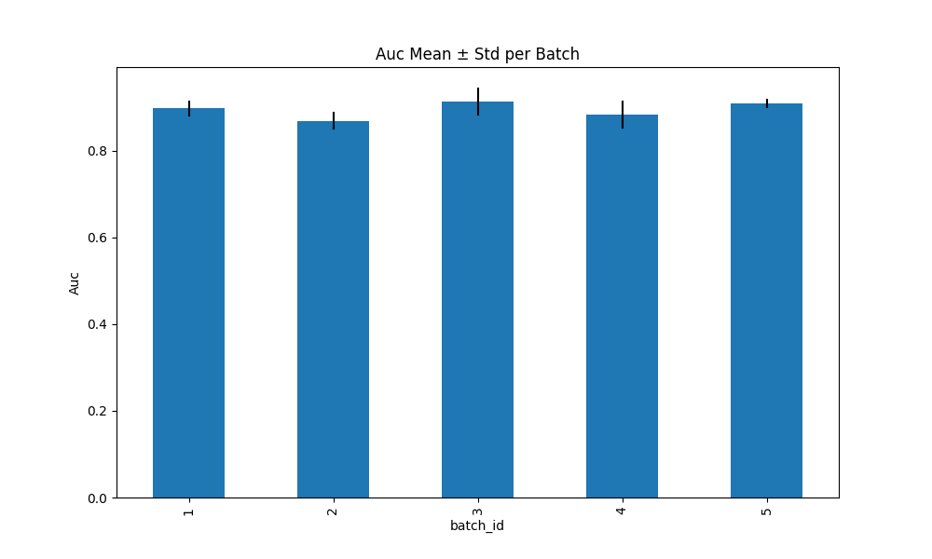

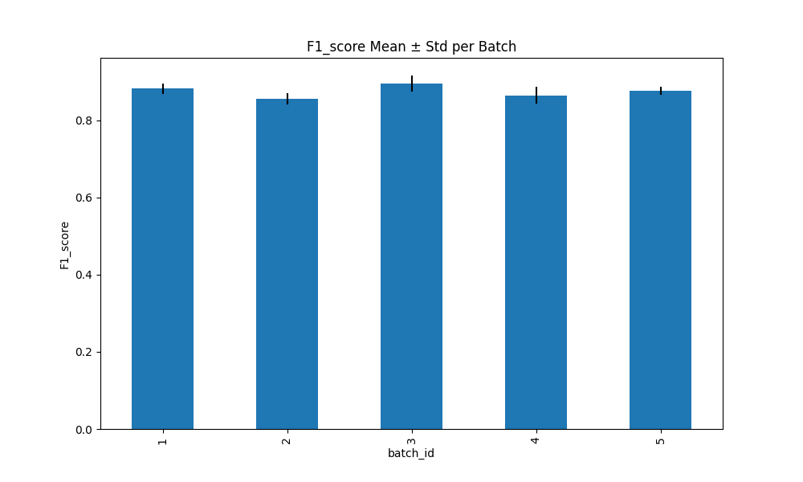

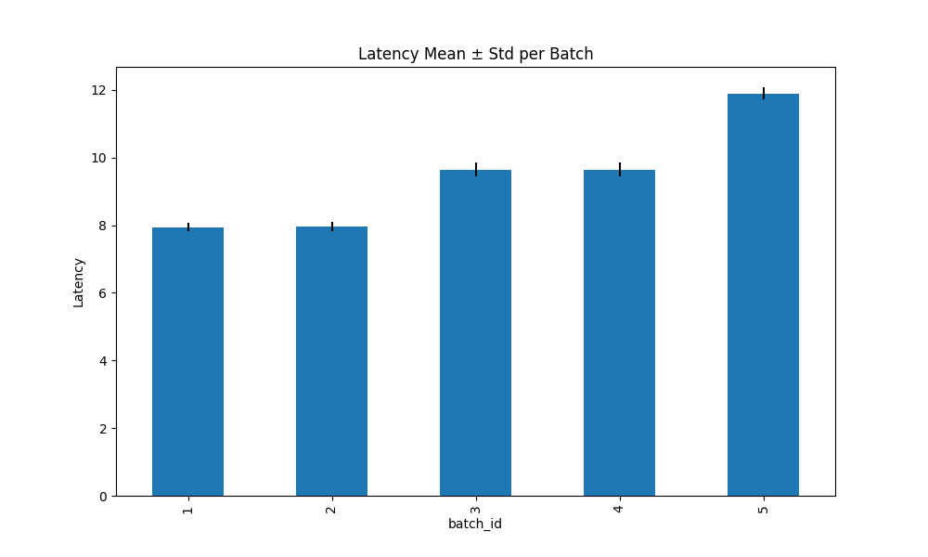

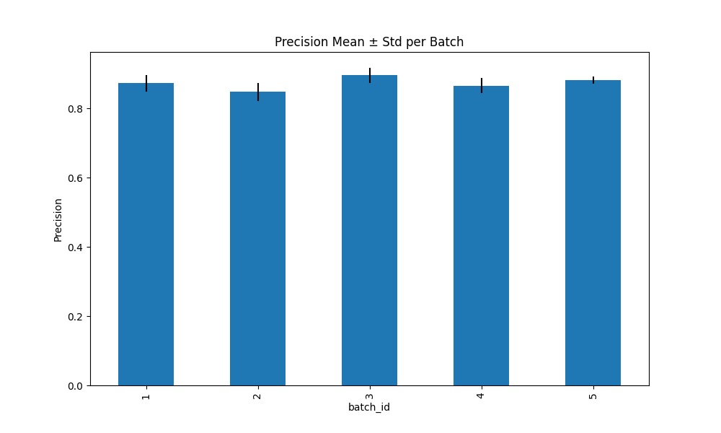

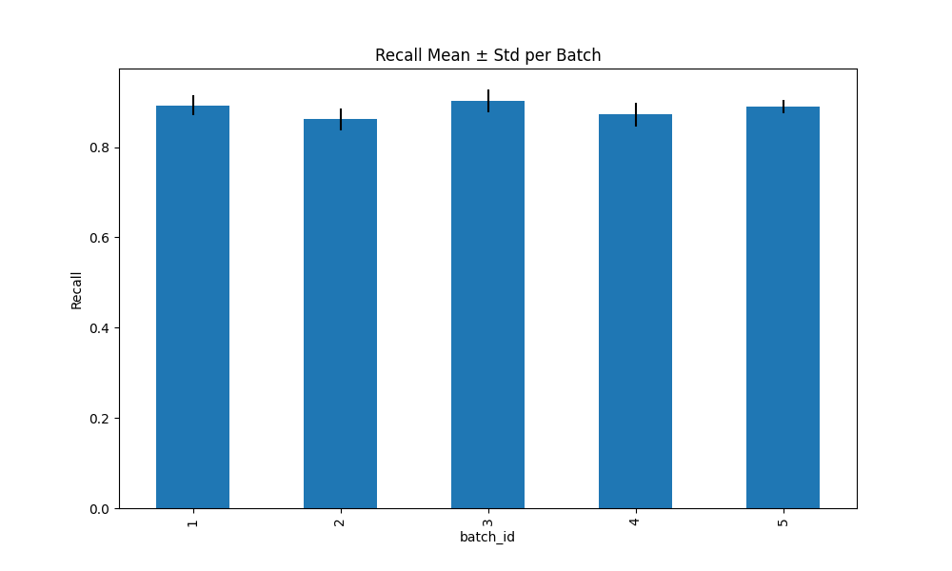

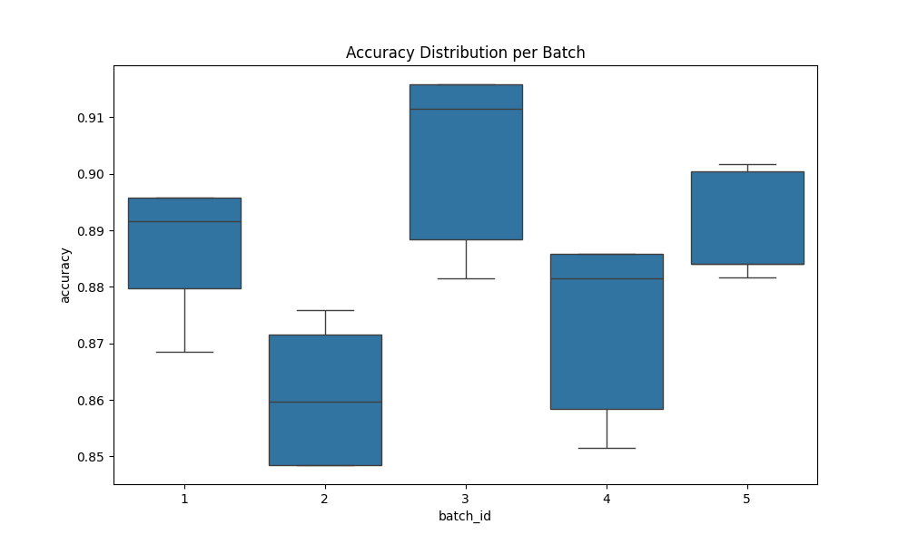

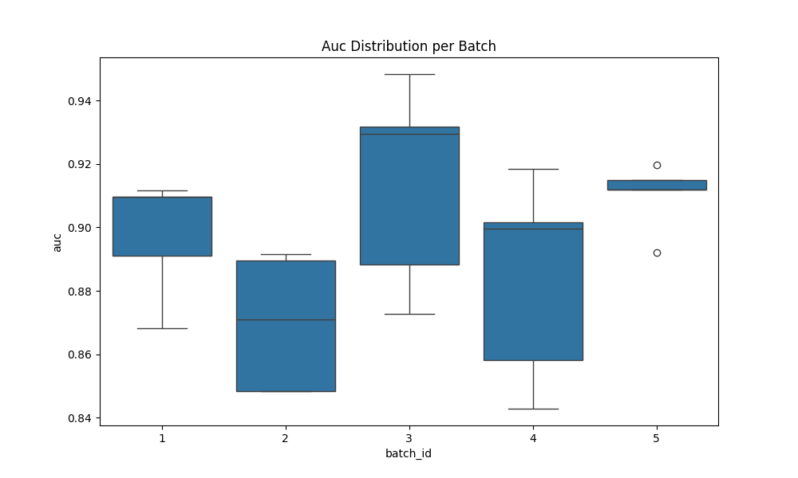

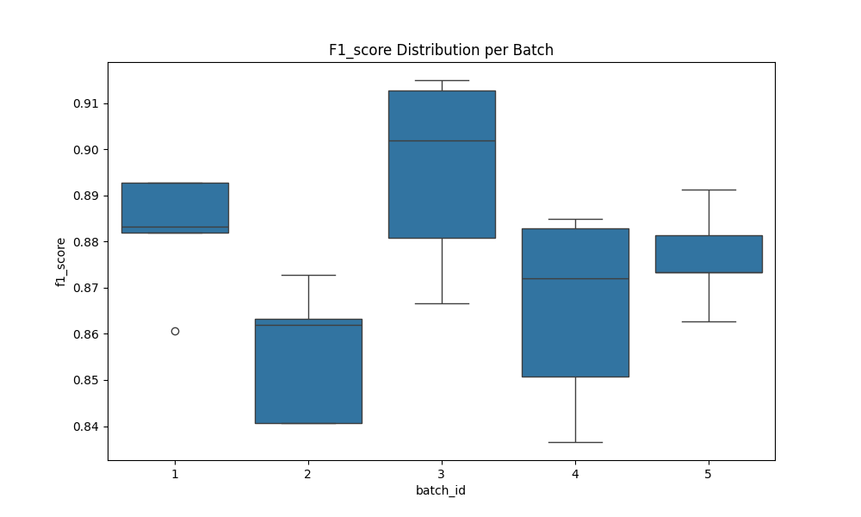

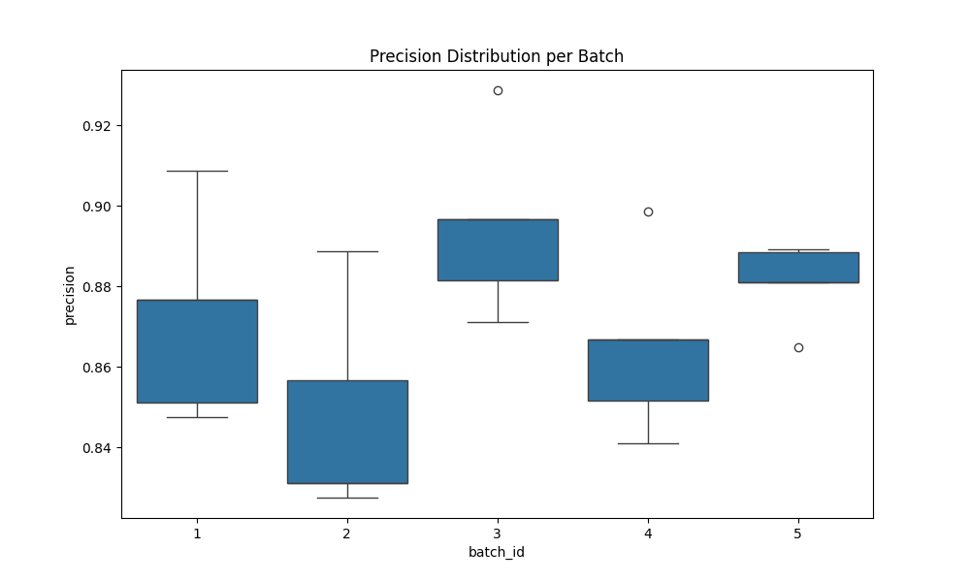

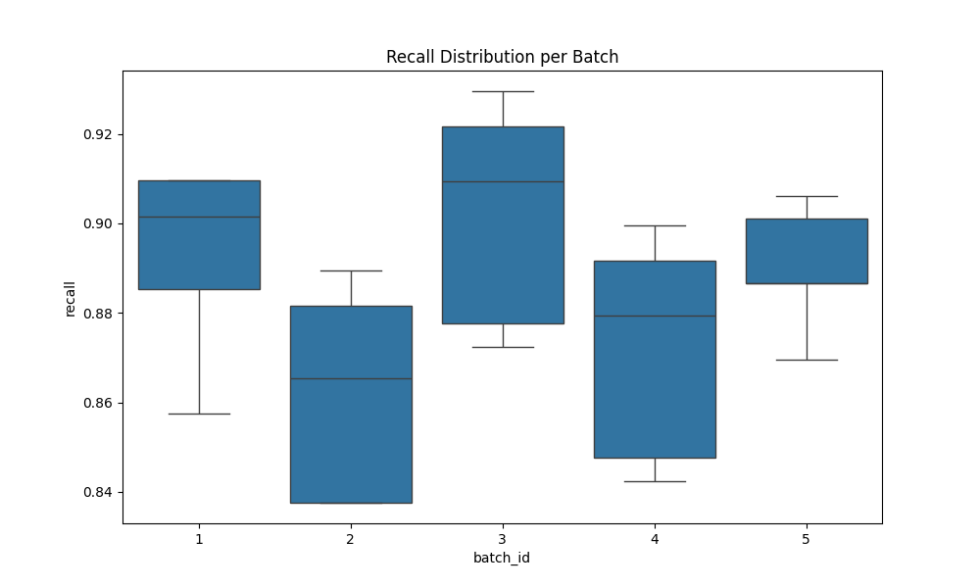

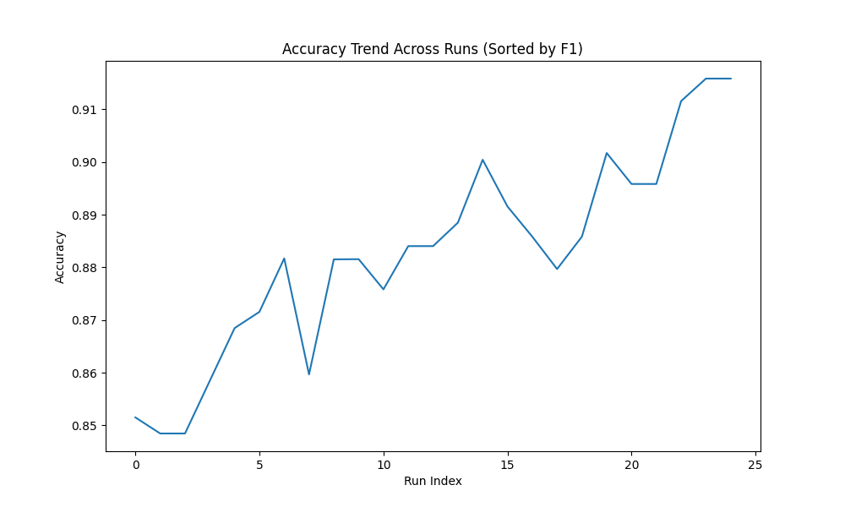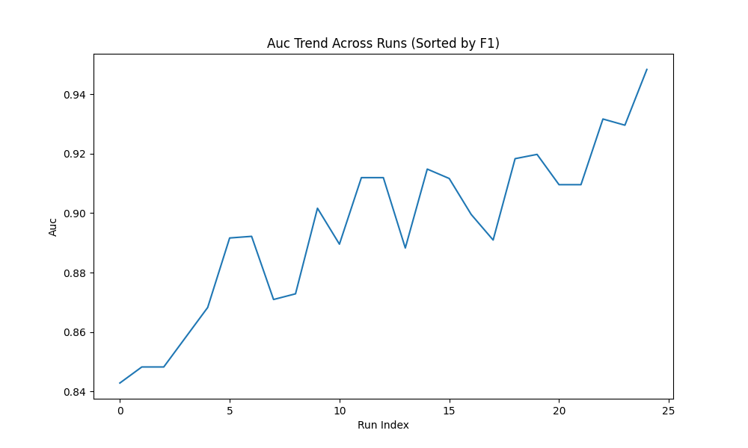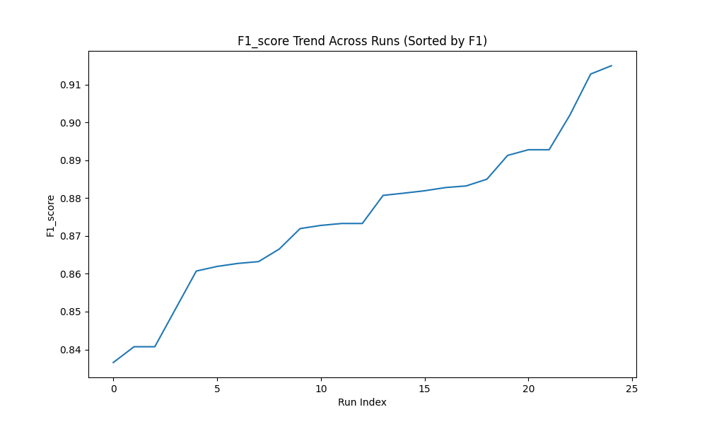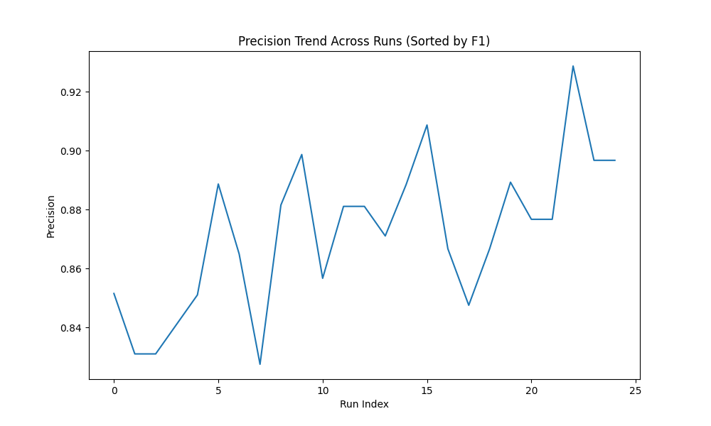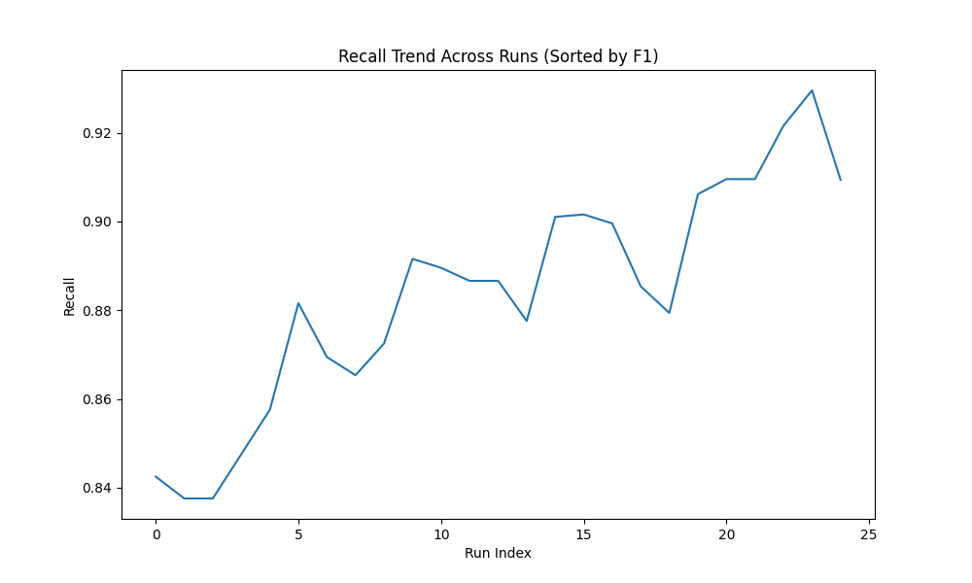

6. Key Insights & Analysis

• Best Performing Metric: LATENCY with mean 9.411680
• Most Stable Metric: ACCURACY with std 0.018973
• Highest Variance: LATENCY with variance 2.129293
• Best Run: Batch 3 Run run_4 with F1 0.914991
• Worst Run: Batch 4 Run run_5 with F1 0.836546
• Total evaluation samples: 150 across 5 batches

